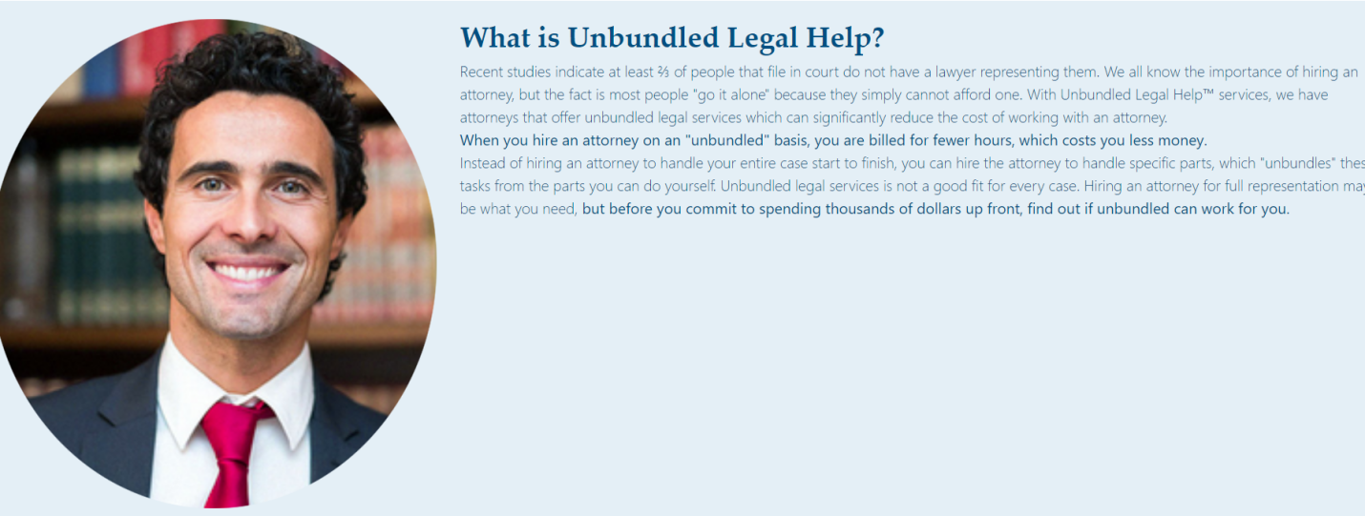

What is Affordable Legal Help

Millions of people each year are forced to face legal challenges on their own. Affordable Legal Help is a coalition of experienced and caring lawyers that want to see that problem end. We believe that you shouldn’t ever have to go without legal help simply because it is too expensive and that’s why the attorneys in our network have optimized their services and made them available individually to save you money and protect you from undeserved legal consequences. We will be at your side to face your case and provide you with quality legal assistance that almost anyone can afford. Call us today for help with your legal challenge and to start working with an attorney that cares about helping--not just money.

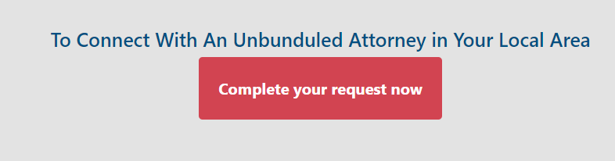

Connect With An Affordable Attorney In Your Area Today



Affordable Legal Help helped me in finding a lawyer that I was comfortable with to work with me through my pending divorce. It was a very trying time, but they provided a service that relieved much of my stress.

My attorney reached out to me right away to learn more about my case and present to me a legal plan for gaining custody of my daughter. I won my case and I couldn’t be more happy with my attorney.

I was able to connect quickly with a firm that handled bankruptcies to handle my ongoing claim. They helped me navigate a very difficult part of my life.

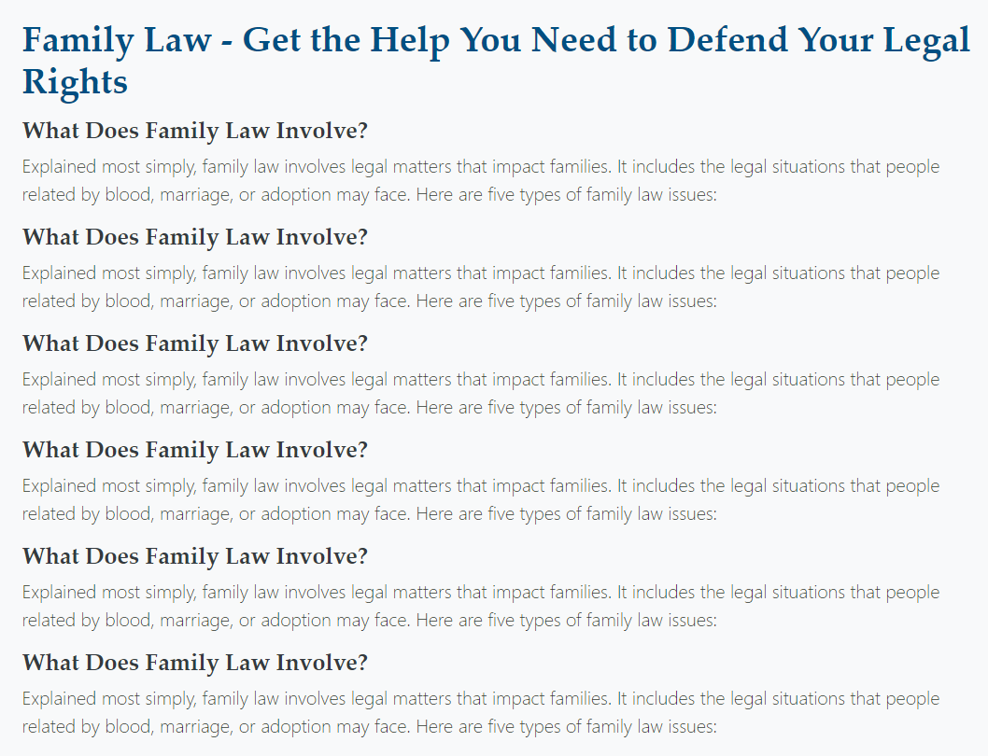

Why Choose Our Lawyers?

**Experienced**

Each of the attorneys and firms in our proven network has decades of experience serving other individuals in your area. They can serve a variety of needs and even address the most unique cases.

**Friendly**

The lawyers in our network really care about getting you the help that you need and will treat you with dignity, respect, and communication every step of the way. If you want an attorney that you like to work with, choose one in our network.

**Affordable**

The attorneys in the Affordable Legal Help network live up to their title and are happy to provide legal assistance that can be used by anyone--even those on a tight budget.

**Local**

Our network features thousands of attorneys and firms, and you’ll be able to easily connect with one in your area to make communication much easier and faster.

**Accessible**

You’ll always be able to get in touch with our attorneys. Our lawyers don’t believe in leaving clients in the dark and they’ll be there to answer your questions and address your concerns when you have them.

**Hard-Working**

Our in-network attorneys care about results more than anything. They will fight hard to achieve your desired result and won’t rest until every avenue of legal recourse has been exhausted.